**Program no____9_____**

**Program Title______Fire alert_________**

**Aim The light Fades as the sunlight increases**

**Hardware Required**

* Arduino Board

Piezo

Temperature Sensor

**Circuit Diagram**

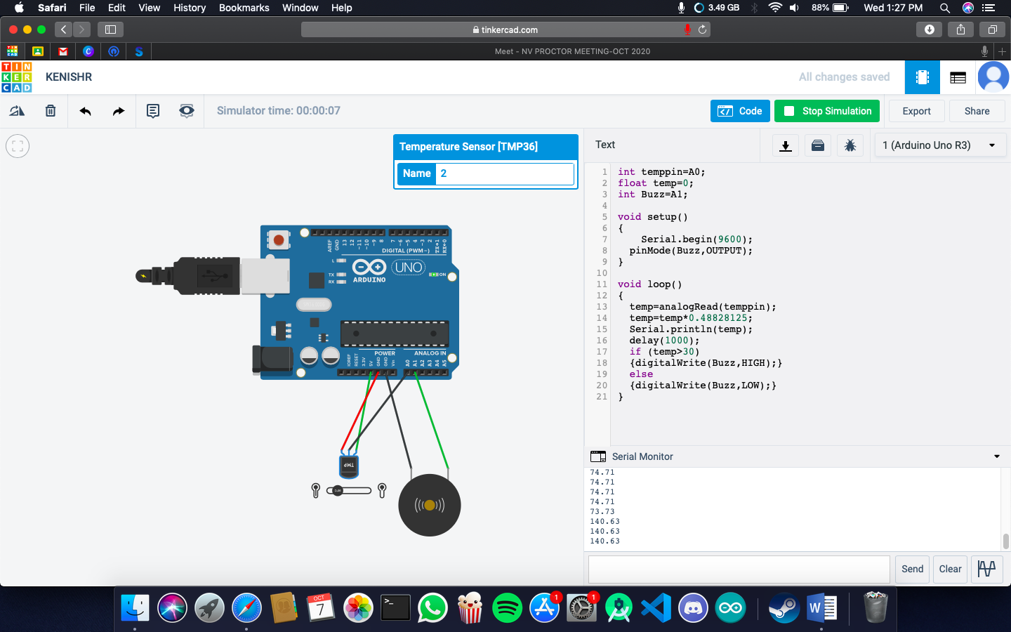

**Code:**

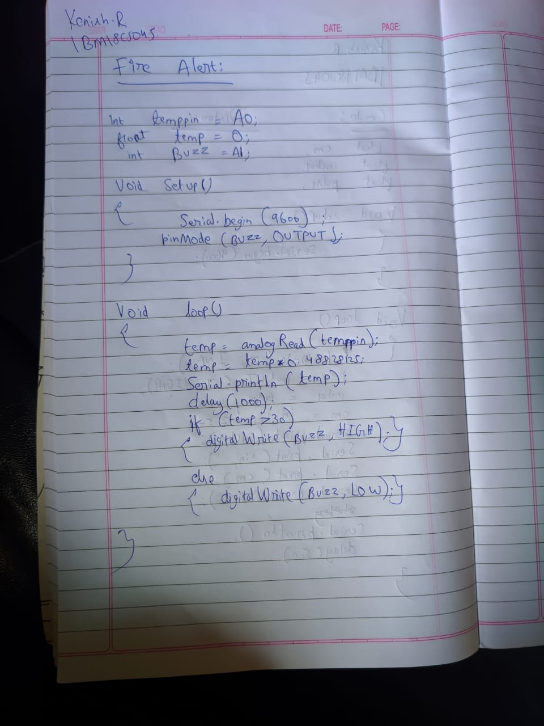

**Observation /Output**

**Fire alert will be triggered.**